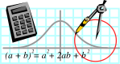  Rossmoyne SHS  Mathematics  Department | 2A MATHEMATICS | Semester 1 2011  EXAMINATION

NAME:
TEACHER: Mr. Fletcher Mr Tanday

Section Two:
Calculator-assumed

Time allowed for this section
Reading time before commencing work: 10 minutes
Working time for this section: 100 minutes

Materials required/recommended for this section

To be provided by the supervisor
This Question/Answer Booklet
Formula Sheet (retained from Section One)

To be provided by the candidate
Standard items: pens, pencils, pencil sharpener, eraser, correction fluid, ruler, highlighters

Special items: drawing instruments, templates, notes on two unfolded sheets of A4 paper, and up to three calculators satisfying the conditions set by the Curriculum Council for this examination

Important note to candidates
No other items may be taken into the examination room. It is your responsibility to ensure that you do not have any unauthorised notes or other items of a non-personal nature in the examination room. If you have any unauthorised material with you, hand it to the supervisor before reading any further.
Structure of this paper

Section | Number of questions available | Number of questions to be answered | Suggested working time  (minutes) | Marks  available
Section One:  Calculator-free |  |  | 50 | 40
Section Two:  Calculator-assumed | 16 | 16 | 100 | 80
 |  |  |  | 120

Instructions to candidates

- The rules for the conduct of Western Australian external examinations are detailed in the Year 12 Information Handbook 2010. Sitting this examination implies that you agree to abide by these rules.

2. Answer the questions according to the following instructions.

Section Two: Write answers in this Question/Answer Booklet. All questions should be answered.
Show all your working clearly. Your working should be in sufficient detail to allow your answers to be checked readily and for marks to be awarded for reasoning. Incorrect answers given without supporting reasoning cannot be allocated any marks. For any question or part question worth more than two marks, valid working or justification is required to receive full marks. If you repeat an answer to any question, ensure that you cancel the answer you do not wish to have marked.
It is recommended that you do not use pencil except in diagrams.

3. You must be careful to confine your responses to the specific questions asked and to follow any instructions that are specific to a particular question.

- Spare pages are included at the end of this booklet. They can be used for planning your responses and/or as additional space if required to continue an answer.
  - Planning: If you use the spare pages for planning, indicate this clearly at the top of the page.
  - Continuing an answer: If you need to use the space to continue an answer, indicate in the original answer space where the answer is continued, i.e. give the page number. Fill in the number of the question(s) that you are continuing to answer at the top of the page.

QUESTION | MARKS AVAILABLE | STUDENT MARK
1 | 2
2 | 2
3 | 3
4 | 3
5 | 3
6 | 5
7 | 5
8 | 4
9 | 5
10 | 4
11 | 9
12 | 6
13 | 3
14 | 6
15 | 8
16 | 7
TOTAL | 80

SECTION B
APPROVED CALCULATORS PERMITTED FOR THIS SECTION
TIME: 100 minutes
MARKS ALLOCATED 80 marks
Question 1 [2 marks]

An employee is on a wage of $650 per week.
What would be the new wage after a 4.5% increase?

Question 2 [2 marks]
After a discount of 12.5% is given, a coffee machine is sold for $367.50
What was the marked price before the discount was given?
Question 3 [3 marks]

The 65 students in the 2AMAT course represent approximately 17.5% of the Year 11 population. How many students are there in Year 11 (give answer to nearest whole number)?

Question 4 [3 marks]

The volume of a gas is directly proportional to its temperature in degrees Kelvin (⁰K).
If a gas has a volume of 26 L at 300⁰K, find its volume at 375⁰K.

Question 5 [3 marks]

The volume of a different gas is inversely proportional to the pressure applied to it. If the volume of a gas is 65L when a pressure of 1 450 kPa is applied, find the volume when a pressure of 900 kPa is applied. ( Do not round answer)

Question 6 [2. 3 = 5 marks]

A boat sails 15.35km due North, then changes direction to due West for 3.65 km.
(a) Draw a detailed diagram to represent this situation.

(b) Calculate the distance from its starting point.

Question 7 [5 marks]

Calculate the lengths of the sides marked x and y in the diagram at right. | 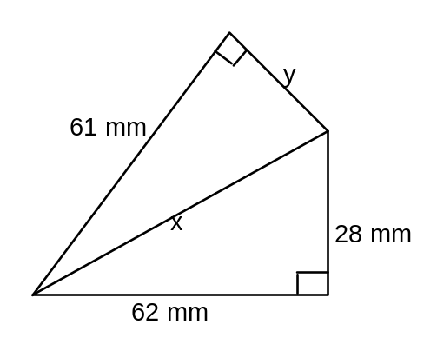

Question 8 [2, 2 = 4 marks]
The figure at right is a rectangular prism. Calculate the lengths of:-  (a) AC  (b) AY | 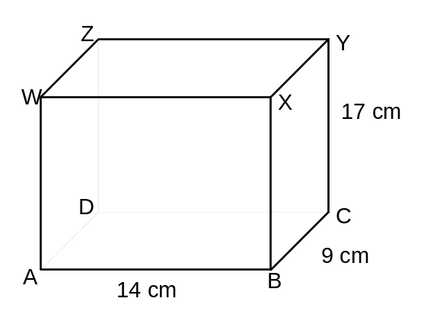

Question 9 [2, 3 = 5 marks]

Give answers to this question to 2 decimal places for full marks
One of the equations of motion is
v = 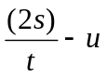

(a) Find v if u = 7.8, s = 10.75 and t = 2.4

(b) Find s if v = 11.23, u = 27.48 and t = 25.34

Question 10 [4 marks]

Which of the following boxes of Melloggs Crunchy Earwigs breakfast cereal is the best buy?
Justify your answer (i.e. working must be shown).

Note: buying in bulk is not always the cheapest, or is it!!
A: 1.75 kg for $12.10
B: 1.25 kg for $8.65
C: 750 g for $5.20
Question 11 [6, 3, 3 = 9 marks]
Determine the mean, mode and median from the following dot frequency graph:-

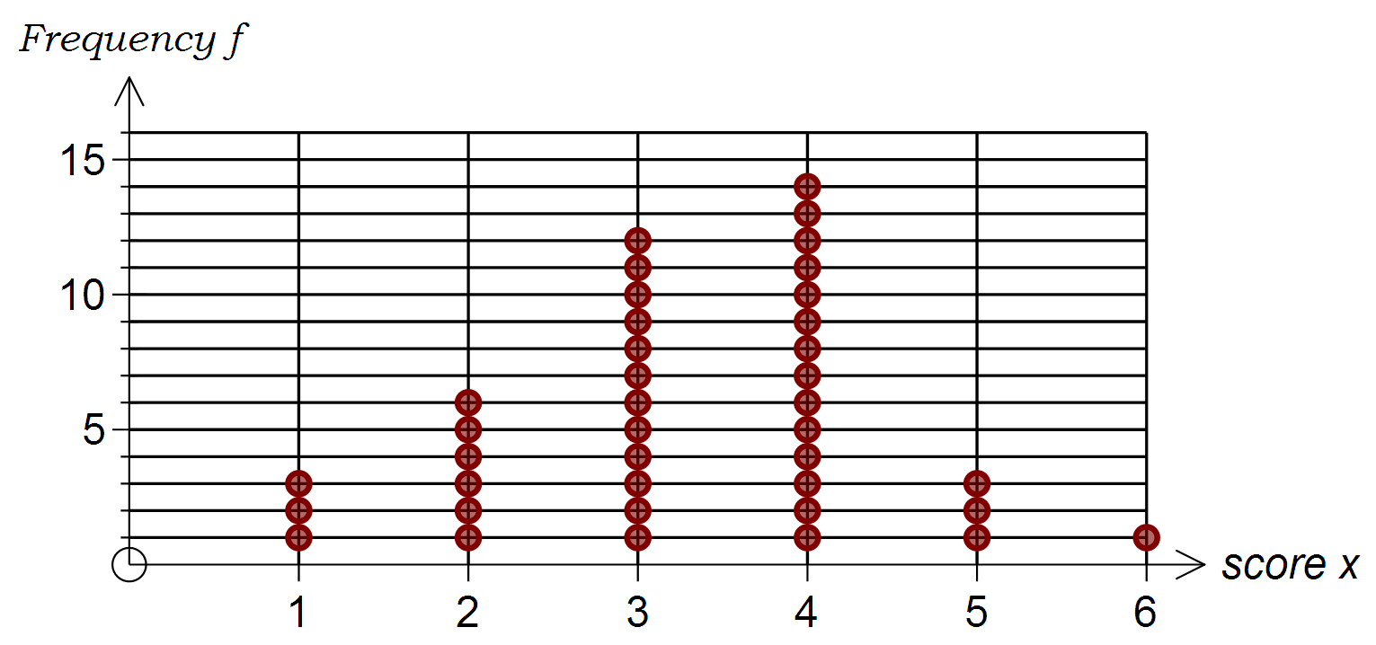

Answers: Mean= Mode= Median=
(3marks) (1 mark) (2 marks)

- The eleven (11) girls in a class had a mean mark of 67.5%, and the ten (10) boys had a mean mark of 59.5%.
What was the mean mark for the whole class?

- The following table shows the ages of people at a picnic spot.

Age | 0 - 9 | 10 - 19 | 20 - 29 | 30 - 39 | 40 - 49 | 50 - 59
Number of people | 20 | 9 | 8 | 14 | 7 | 2
Calculate the approximate mean age of the people at the picnic spot.

Question 12 [6 marks]
After paying his rent, an apprentice has $275 per week left of his wages. He spends $65 per week on payments for his car, $55 per week on petrol, $50 per week on entertainment, $35 per week is set aside for savings, and the rest is spent on other items.
Show where his money goes each week by drawing a pie chart (circle graph) to show how the $275 is spent. (Divisions below are every 10°)

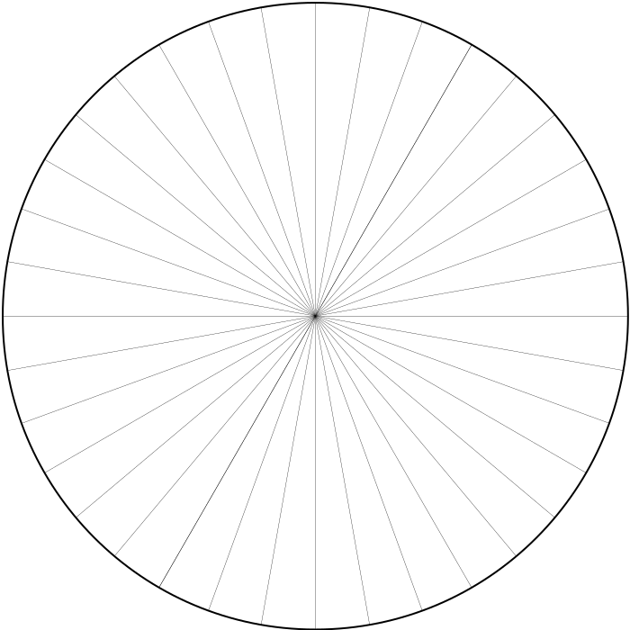
What angle of the graph represents Other items?

________________Deg

Give answer as a recurring decimal.

Question 13 [3 marks]

A salesman is paid a retainer of $625 per week, plus a commission of 6.5% on all sales for that week. One week, he was paid $1090.00. What were his total sales for that week?
Question 14 [3, 3 = 6 marks]
A wholesaler makes a profit of 15% when he sells an article to a retailer. The retailer makes a profit of 10% when he sells it to a customer. If the retailer sells an article to a customer for $1524.36, find
(a) the cost price to the retailer ( to the nearest cent)
Do not use rounded retailers price for working out the wholesalers price.
(b) the cost price to the wholesaler (to the nearest cent)

Question 15 [2, 2, 2, 2 = 8 marks]

A mobile mechanic has a call-out fee of $80 plus a charge of $45 per halfhour.
(a) Graph this relationship on the axes below

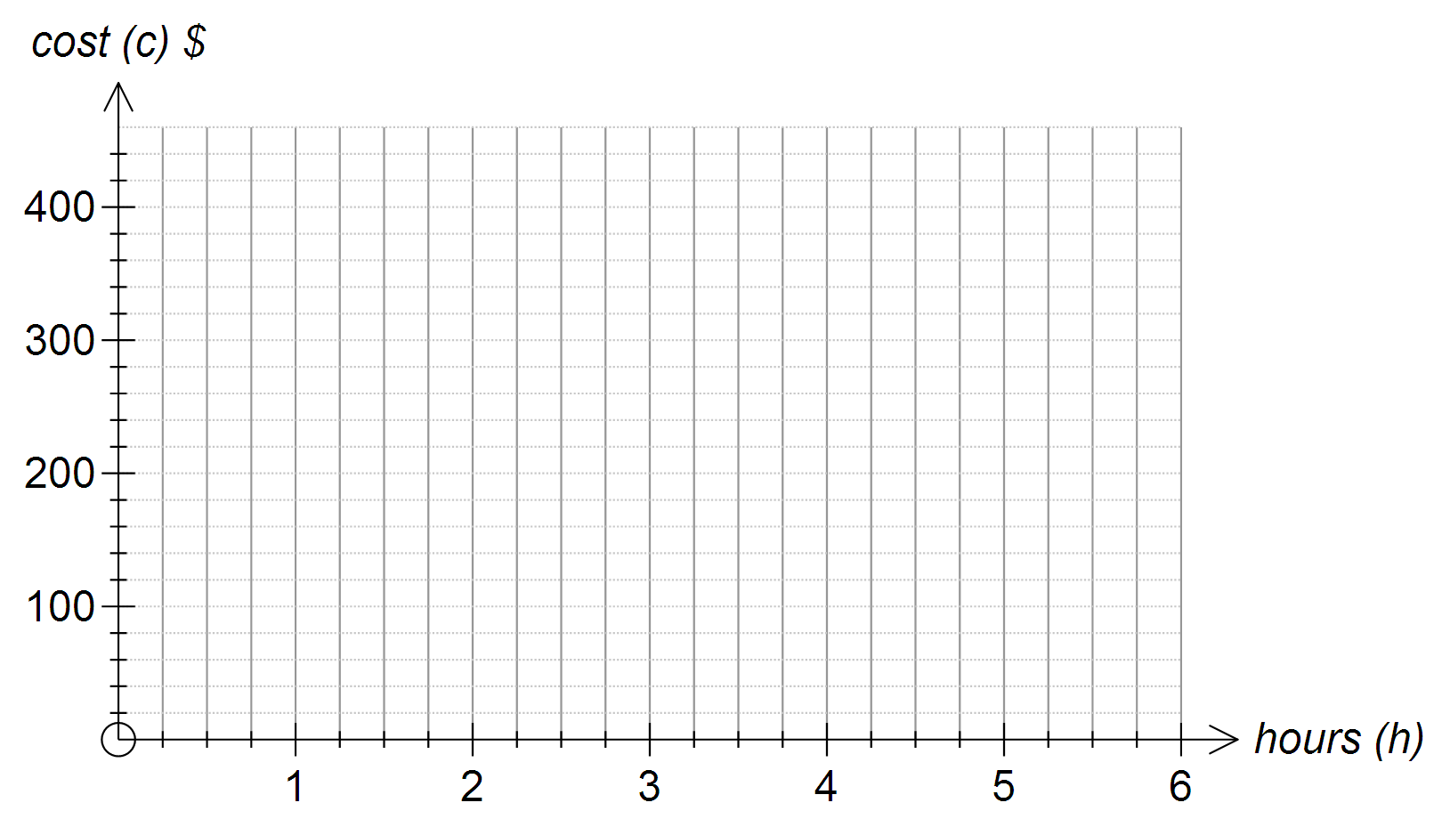

(b) If h is the number of hours worked and c is the total cost (in $), write down an expression for c in terms of h.
________________________
(c) Find c if h = 4
(d) Find h if c = $300

Question 16 [3, 1, 3 = 7 marks]

Subject | Biology | English | History | Phys Ed | Art | Maths 2A
Mark (%) | 64 | 60 | 68 | 72 | 58
In the Semester 1 Exams, Kylie scored the above marks. Her mark for Maths 2A is missing, but her mean mark over all six subjects was 68%.
(a) What was her mark for Maths 2A?
(b) What was her median mark?
(c) Bruce’s marks for the same six subjects were, in ascending order,
42%, x%, 66%, y%, 73%, z%
His range of marks was 43%, his modal mark was 66%,
and his median mark was 69%.
Find x, y and z

Answers x= y= z=

END OF SECTION B
GO BACK AND CHECK ALL QUESTIONS ANSWERED, CHECK WORKING

